Alexander Vinnik

alexander.vinnik@codex.team

This functional specification document outlines the high-level design and features for the “Workouts” and “Activity” tabs of the Nike Training Club (NTC) mobile application.

Nike Training Club (NTC) mobile app

Functional Design Specification Document

Table of Contents

1. Introduction 3

1.1. Objective: 3

1.2. Scope: 3

2. Assumptions and Dependencies 3

3. Requirements 3

4. Epic: Workouts Tab 4

4.1. US-001: Personalized Workout Recommendations (For You Section) 4

4.2. US-002: Workout Categories (Browse Section) 5

4.3. US-003: Guidance Section 6

4.4. US-004: Meet Our Trainers (Bios Section) 7

4.5. US-005: Workout Details (Workout Screen) 8

5. Epic: Activity Tab 10

5.1. US-001: View Workout History 11

5.2. US-002: View Total Activities and Minutes 12

5.3. US-003 View Detailed Activity 12

5.4. US-004: View Achievements and Milestones 13

5.5. US-005: Track Workout Streaks 14

5.6. US-006: View Trophies for Challenges 15

5.7. US-007: View Weekly Workouts 16

**Version History**

|  |  |  |  |
| --- | --- | --- | --- |
| Version | Date | Author | Description of Change |
| Draft | 15.10.2024 | Alxander Vinnik | Initial version |
|  |  |  |  |
|  |  |  |  |

# Introduction

## Objective:

This document outlines the functional specifications for the “Workouts” and “Activities” tabs of the Nike Training Club (NTC) mobile app. It describes UI elements, user stories, functionalities, and business logic. The app is focused on providing users with workout routines, activity tracking.

## Scope:

• **UI Design**: “Workouts” and “Activities” tabs.

• **User Stories**: Functional requirements and business logic for users interacting with workouts and activity tracking.

• **Trackers**: Performance tracking during workouts.

• **Business Logic**: User interactions, including workout selection, performance tracking, and achievements.

# Assumptions and Dependencies

|  |  |
| --- | --- |
| ID | Assumption Description |
| AS-01 | The design is based on provided screenshots of the NTC app |

# Requirements

|  |  |  |  |
| --- | --- | --- | --- |
| ID | Requirement Description | Priority | Status |
| FR-001 | Users must be able to explore and select workouts from various sections. | High | To Do |
| FR-002 | Users must be able to track completed workouts and monitor achievements. | High | To Do |
| FR-003 | Users can view detailed bios of trainers and select workouts based on their programs. | High | To Do |
| FR-004 | Users must be able to view history of completed activities with time and performance data. | High | To Do |
| FR-005 | Achievements must be displayed based on completed workouts and milestones. | High | To Do |

# Epic: Workouts Tab

This section provides an in-depth understanding of the Workouts Tab, including the major functionalities, user stories, UI components, and business logic. Developers can use this design to build the features and interactions required for users to engage with workout content efficiently.

The “Workouts” tab helps users discover and engage with workout routines. This tab has multiple sections like “For You,” “Browse,” “Guidance,” “Bios,” and detailed workout screens. Each section focuses on a personalized user experience for selecting and performing workouts.

**User Flow:**

1. **For You:** When the user opens the Workouts tab, the personalized “For You” section is displayed, showing a list of workouts recommended for the user based on previous activity and preferences.

2. **Browse:** Users can click on “Browse” to explore workouts by category and filter based on specific interests (e.g., duration, difficulty).

3. **Guidance:** Users can click on the “Guidance” section to access educational content and tips from Nike experts. This section provides users with advice on nutrition, wellness, and performance enhancement to complement their workout routines.

4. **Bios:** Clicking on the “Bios” tab allows users to explore trainer profiles, where they can view the trainer’s bio, career highlights, and associated workouts.

5. **Workout Details:** Selecting any workout from the list brings users to the detailed workout screen, where they can review the exercises and start the session.

|  |  |  |
| --- | --- | --- |
| ID | Title | User story |
| US-001 | Personalized Workout Recommendations (For You Section) | As a user, I want to receive personalized workout suggestions based on my activity history and preferences so I can easily find workouts that match my fitness goals. |
| US-002 | Workout Categories (Browse Section) | As a user, I want to browse workouts by different categories (e.g., strength, cardio, yoga) so I can select workouts based on my current fitness interests. |
| US-003 | Guidance Section | As a user, I want to view educational content and tips from experts so I can enhance my workout performance and improve my overall wellness. |
| US-004 | Meet Our Trainers (Bios Section) | As a user, I want to view trainer profiles so I can learn more about the trainers and choose workouts based on their expertise. |
| US-005 | Workout Details (Workout Screen) | As a user, I want to view detailed workout instructions and start a workout so I can follow a structured routine and complete my exercises effectively. |

## US-001: Personalized Workout Recommendations (For You Section)

As a user, I want to receive personalized workout suggestions based on my activity history and preferences, so I can easily find workouts that suit my fitness goals.

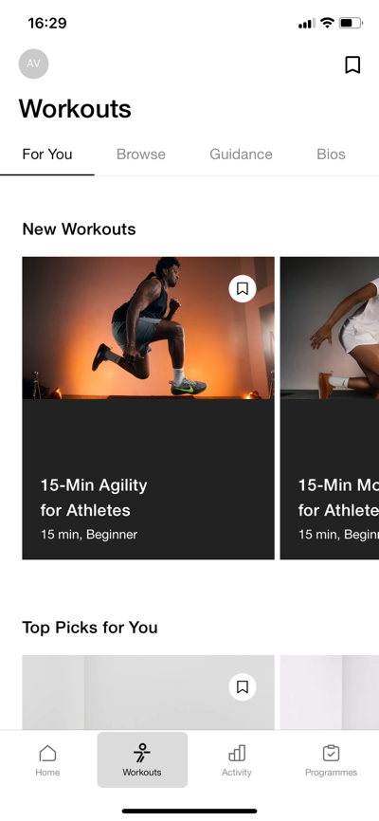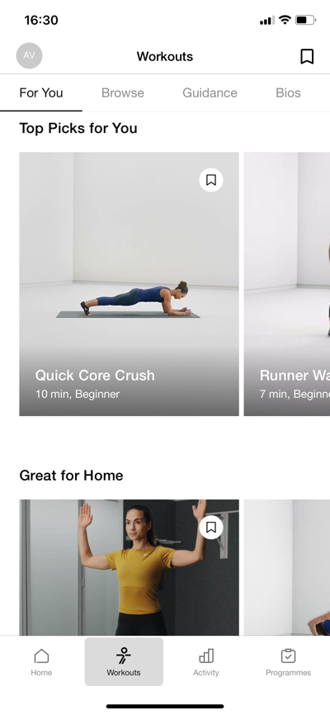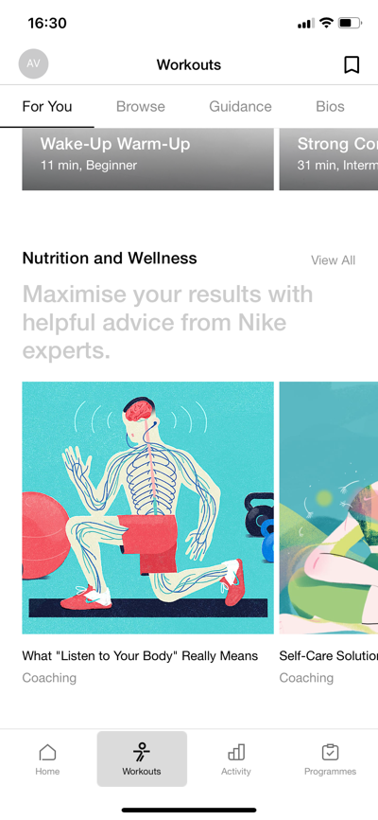

**Acceptance Criteria:**

• Personalized recommendations are displayed at the top of the “For You” section based on past activities.

• Workout cards include the title, duration, and difficulty level.

• Users can click a workout to view its detailed information and start the session.

**UI Elements:**

• Workout Cards (e.g., “15-Min Agility for Athletes”, “Quick Core Crush”)

• Filters for workout categories

**Business Logic:**

• The system uses user activity data and preferences to suggest relevant workouts.

• Recommendations update dynamically based on recent user actions and workout history.

## US-002: Workout Categories (Browse Section)

As a user, I want to browse workouts by different categories (e.g., strength, cardio, yoga) so that I can choose a workout based on my current fitness interests.

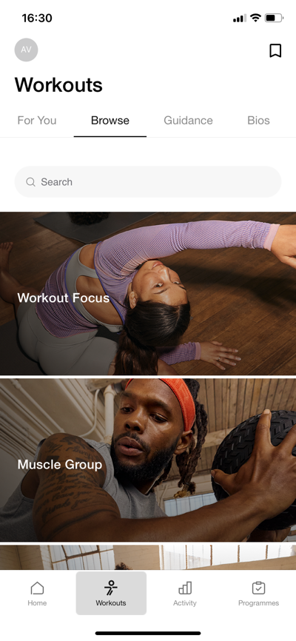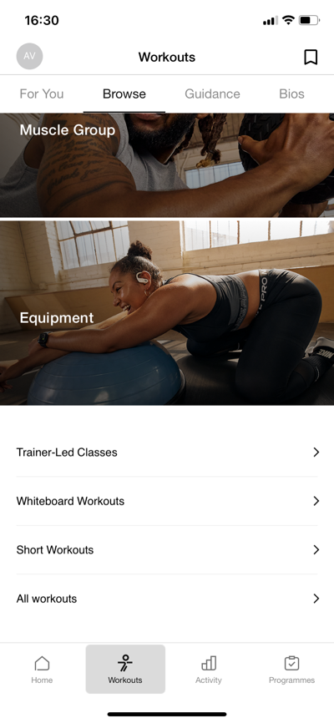

**Acceptance Criteria:**

• Users can view a categorized list of workouts (e.g., “Strength Training”, “Yoga”, “Cardio”).

• Users can click on a category to see all related workouts.

• Users can filter workouts by intensity level, trainer, or workout duration.

**UI Elements:**

• Category List: As shown in the screenshots, categories like "Workout Focus," "Muscle Group," and "Equipment" are available.

• Workout Thumbnails: These include images and relevant workout information, such as titles, which match the descriptions in the specification.

**Business Logic:**

• Workouts are grouped into predefined categories.

• Filters apply dynamically to show relevant results.

## US-003: Guidance Section

As a user, I want to view educational content and tips from experts so that I can enhance my workout performance and overall wellness.

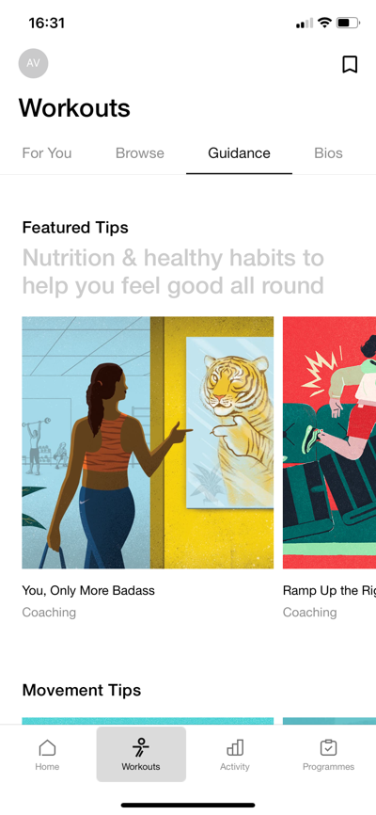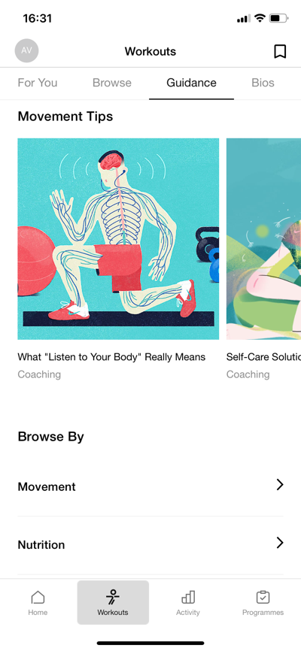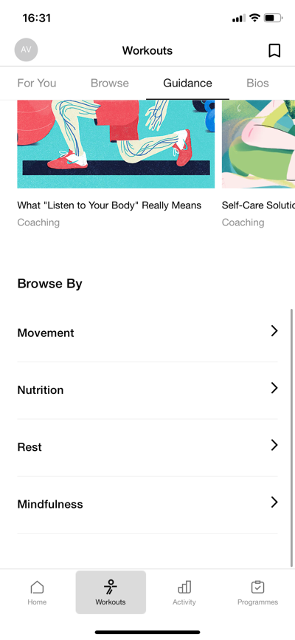

**Acceptance Criteria:**

• The “Guidance” section offers articles, videos, and tips (e.g., “What ‘Listen to Your Body’ Really Means”).

• Users can view a list of educational content filtered by category (e.g., Nutrition, Wellness).

• Users can click on an article or video to view it in detail.

**UI Elements:**

• Article and Video Thumbnails

• Category Filters (e.g., Nutrition, Wellness)

**Business Logic:**

• Content is curated based on user interests and interactions with the app.

• Educational content updates regularly based on new uploads and user engagement.

## US-004: Meet Our Trainers (Bios Section)

As a user, I want to view trainer profiles so that I can learn more about the trainers and choose workouts based on their expertise.

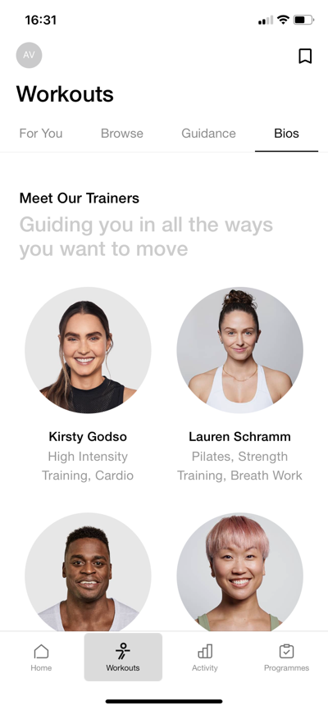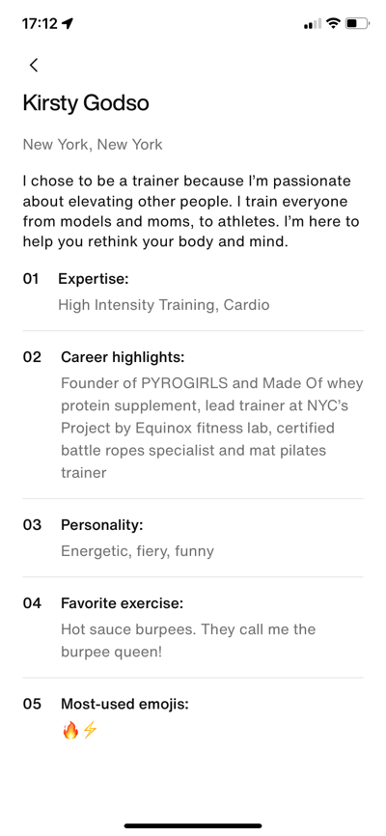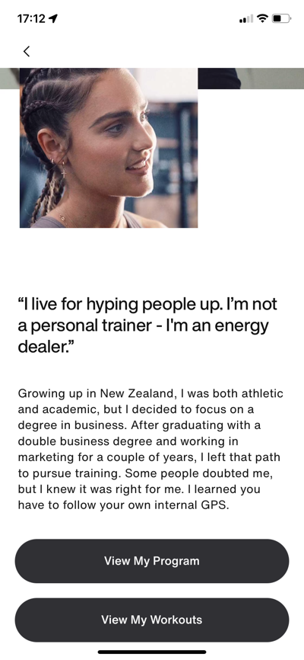

**Acceptance Criteria:**

• Trainer profiles display a bio, expertise, and career highlights (e.g., “Kirsty Godso - High Intensity Training, Cardio”).

• Users can click on a trainer’s profile to see more details, including their workouts and programs.

• A user can filter workouts based on trainer specialization.

**UI Elements:**

• Trainer Profile Cards

• “View My Program” and “View My Workouts” Buttons on each Trainer’s Profile

**Business Logic:**

• Trainers are displayed based on their popularity and user engagement with their workouts.

• Trainer profiles include a list of associated workouts and programs.

## US-005: Workout Details (Workout Screen)

As a user, I want to view detailed workout instructions and start a workout so that I can follow a structured routine.

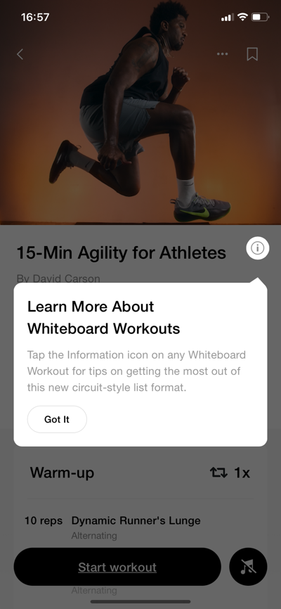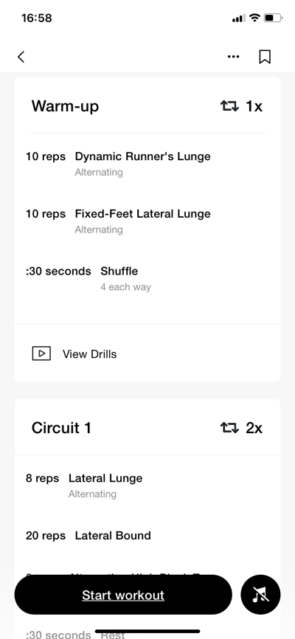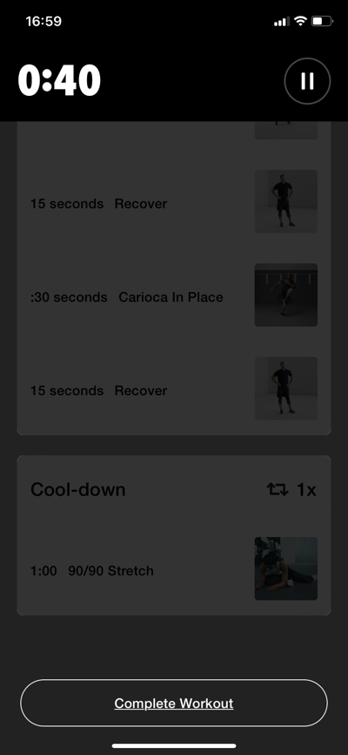

**Acceptance Criteria:**

• Workout details include warm-up, workout circuits, and cool-down sections.

• The workout screen provides instructions for each exercise (e.g., reps, sets, rest times).

• Users can start a workout session and track their progress in real-time.

• Users can pause, resume, and complete the workout.

**UI Elements:**

• Workout Instructions (e.g., “15-Min Agility for Athletes”, “Dynamic Runner’s Lunge - 10 reps”)

• Start Workout Button

• Timer, Progress Bar, and Exercise Tracking

**Business Logic:**

• Exercise completion is tracked in real-time.

• The system calculates workout scores based on performance metrics (e.g., completed exercises, time taken).

• The workout session data is synced with the user’s activity history.

# Epic: Activity Tab

This section explains the Activity Tab, outlining the primary functionalities, user stories, UI components, and business logic. This tab tracks and monitors the user’s workout activities, milestones, and achievements over time. The users can view a summary of their workout history and track their progress in terms of completed workouts, total minutes, and achievements such as streaks and milestones.

The “Activity” tab consists of two main sections: **History** and **Achievements**. Each section focuses on providing users with a clear overview of their workout journey, helping them stay motivated and consistent in their fitness goals.

**User Flow:**

1. **History**:

• When a user opens the Activity tab, they are greeted with the **History** section, which displays a record of completed workouts.

• The history page summarizes the total number of activities, total minutes spent working out, and lists all completed workouts by date.

• Users can view details of each workout by clicking on an entry, which displays specific information (e.g., type of activity, duration, and date).

2. **Achievements**:

• The **Achievements** section highlights the user’s accomplishments such as completed milestones (e.g., number of workouts) and earned trophies.

• Users can view trophies related to specific challenges or milestones such as “1 Workout,” “7 Workouts,” or “Night Owl” based on their workout patterns.

• The **Achievements** section also tracks streaks and weekly workout frequencies, motivating users to stay consistent.

|  |  |  |
| --- | --- | --- |
| ID | Title | User story |
| US-001 | View Workout History | As a user, I want to see a log of my completed workouts so I can track my fitness progress. |
| US-002 | View Total Activities and Minutes | As a user, I want to view the total number of activities and minutes spent on workouts. |
| US-003 | View Detailed Activity | As a user, I want to click on an individual activity to see specific details like date, type, and duration. |
| US-004 | View Achievements and Milestones | As a user, I want to view my milestones (e.g., number of workouts) and trophies earned to stay motivated. |
| US-005 | Track Workout Streaks | As a user, I want to track my workout streaks so I can stay motivated to continue working out regularly. |
| US-006 | View Trophies for Challenges | As a user, I want to see the trophies I’ve earned from challenges (e.g., “Night Owl”) for recognition. |
| US-007 | View Weekly Workouts | As a user, I want to see how many workouts I’ve completed in a week so I can maintain my consistency. |

## US-001: View Workout History

As a user, I want to see a log of my completed workouts so I can track my fitness progress.

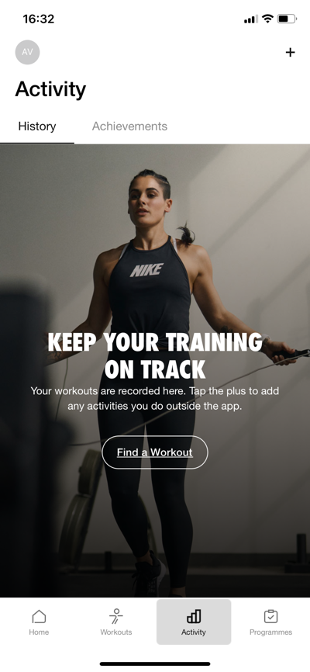

**Acceptance Criteria:**

• The History section displays all previous activities in chronological order.

• Each activity entry includes the type of workout, date, and duration.

• Users can scroll through the history to view older activities.

**UI Elements:**

• Activity Log Entries (e.g., “American Football, Tue, 15 Oct, 1:00”).

• Total Activities and Total Minutes Summary.

**Business Logic:**

• Completed workouts are automatically logged in the history after the user finishes each session.

• The system calculates and displays the total number of activities and minutes based on the user’s workout history.

## US-002: View Total Activities and Minutes

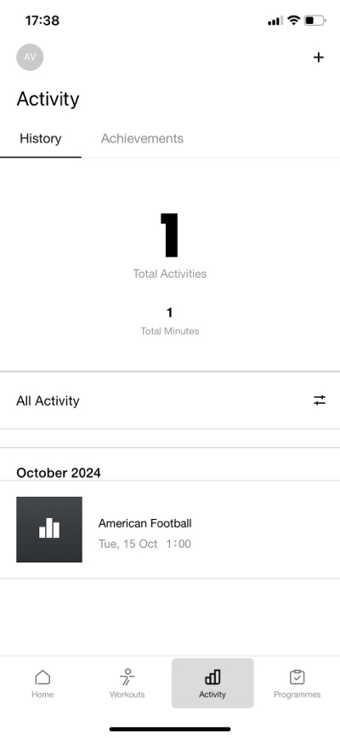

As a user, I want to view the total number of activities and minutes spent on workouts.

**Acceptance Criteria:**

• The **Total Activities** and **Total Minutes** are displayed at the top of the **History** page.

• The totals update dynamically as new workouts are logged.

**UI Elements:**

• Total Activities Counter.

• Total Minutes Counter.

**Business Logic:**

• The system calculates the sum of all completed activities and workout durations.

• Totals update in real-time as new workouts are added.

## US-003 View Detailed Activity

As a user, I want to click on an individual activity to see specific details like date, type, and duration, so I can review my past workout sessions in detail and share in social networks.

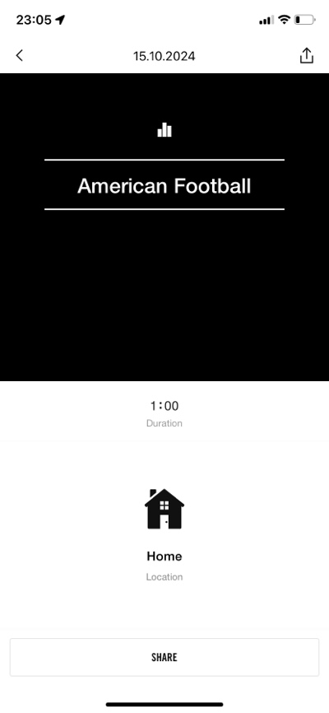

**Acceptance Criteria**:

• Users can click on any activity in the activity log to open a detailed view.

• The detailed view displays the following information:

• Date of activity

• Type of workout (e.g., strength, cardio)

• Duration of the workout.

**UI Elements**:

• Activity List Item (clickable)

• Detailed Activity View (with date, type, duration)

• Share (button)

**Business Logic**:

• Upon clicking an activity, the app retrieves and displays detailed information for that specific session.

• The system ensures that all relevant data (date, type, duration, etc.) is correctly associated with each activity logged.

• Upon clicking share button user is able to share activity in social networks, including photo, posters, and background selection.

## US-004: View Achievements and Milestones

As a user, I want to view my milestones (e.g., number of workouts) and trophies earned to stay motivated.

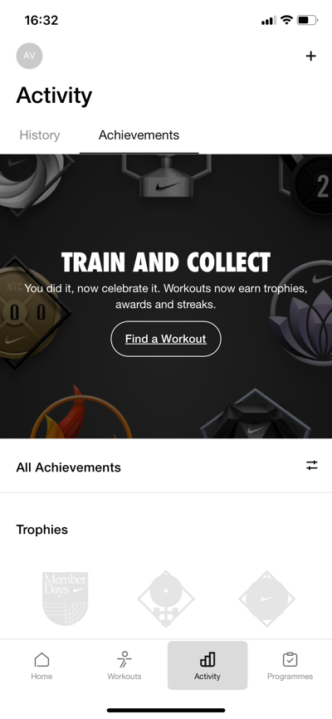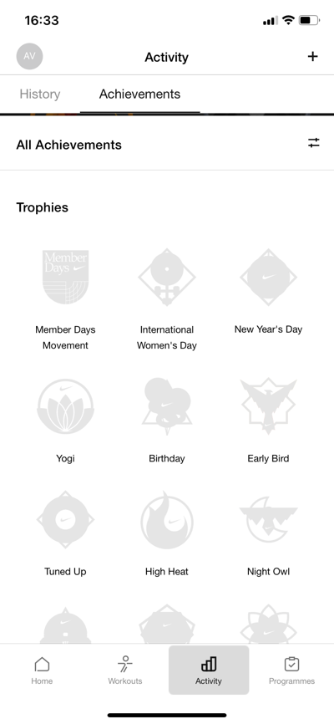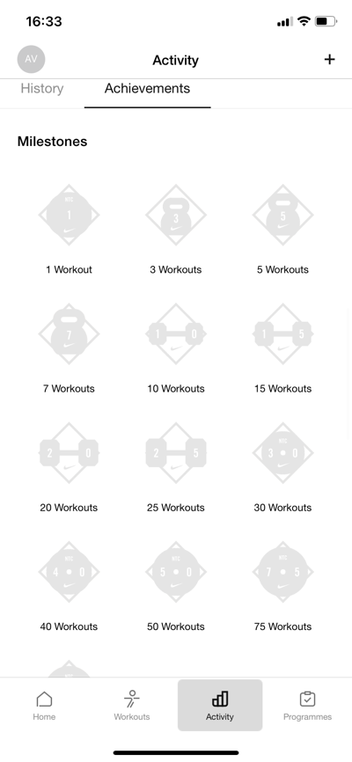

**Acceptance Criteria:**

• Users can see milestones like “1 Workout,” “5 Workouts,” etc., based on their progress.

• Trophies earned for specific challenges or accomplishments (e.g., “High Heat,” “Yogi”) are displayed under **Achievements**.

• Trophies can be greyed out until they are earned.

**UI Elements:**

• Trophy Icons (e.g., “Member Days,” “International Women’s Day”).

• Milestone Badges for completed workouts.

**Business Logic:**

• Trophies are unlocked as users complete specific challenges or hit predefined milestones.

• Milestones like “3 Workouts,” “10 Workouts,” and streaks update automatically as users log more workouts.

## US-005: Track Workout Streaks

As a user, I want to track my workout streaks so I can stay motivated to continue working out regularly.

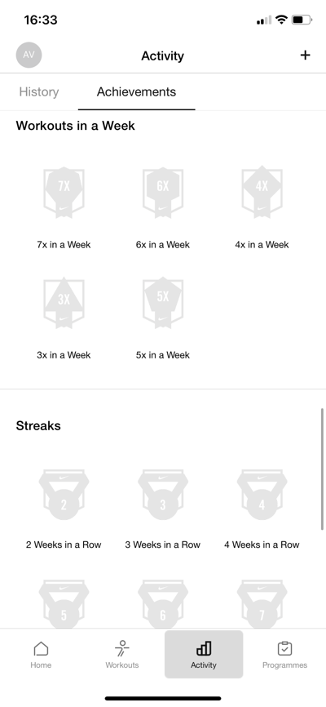

**Acceptance Criteria:**

• Users can see a section in **Achievements** for their workout streaks (e.g., “3 Weeks in a Row”).

• Streaks are displayed based on the number of consecutive weeks the user completes at least one workout.

• Streak progress resets if the user misses a week.

**UI Elements:**

• Streak Badges (e.g., “3 Weeks in a Row,” “5 Weeks in a Row”).

**Business Logic:**

• Streaks update automatically every week.

• If no workout is logged for a week, the streak is reset.

## US-006: View Trophies for Challenges

As a user, I want to see the trophies I’ve earned from challenges (e.g., “Night Owl”) for recognition.



**Acceptance Criteria:**

• Trophies earned from completing specific challenges are displayed under **Achievements**.

• Trophies are locked or greyed out until they are earned.

**UI Elements:**

• Trophy Icons with descriptions (e.g., “Night Owl,” “Birthday”).

**Business Logic:**

• Trophies unlock based on user actions (e.g., working out at night for “Night Owl”).

• The system checks for trophy conditions and updates accordingly.

## US-007: View Weekly Workouts

As a user, I want to see how many workouts I’ve completed in a week so I can maintain my consistency.



**Acceptance Criteria:**

• Users can see a breakdown of their weekly workout counts in **Achievements**.

• Workout frequency badges are displayed for completing workouts 3x, 4x, or more in a week.

**UI Elements:**

• Weekly Workout Badges (e.g., “3x in a Week,” “7x in a Week”).

**Business Logic:**

• Weekly workout counts reset every Monday.

• The system tracks the number of workouts completed within a 7-day period and updates badges in real-time.